Launching Resources
By Haroon Zaman | December 2025

Introduction
In this project, I aimed to learn how compute resources (EC2 instances) interact with AWS networking components. My goal was to fully understand how public and private EC2 instances work, how they communicate, and how to build a complete network environment using the “VPC and More” option in AWS.
To achieve this, I performed three major tasks:
- Created a Public EC2 Instance
- Created a Private EC2 Instance
- Created a VPC Using “VPC and More”
Launching a Public EC2 Instance
A public EC2 instance is a virtual machine that can be accessed from the internet. It sits inside a public subnet, gets a public IP, and uses a security group that allows incoming connections like SSH or HTTP.
Public EC2s are used when you need direct access from outside AWS—such as testing servers, hosting small applications, or practicing networking.
With this understanding, I proceeded to launch my public EC2 instance.
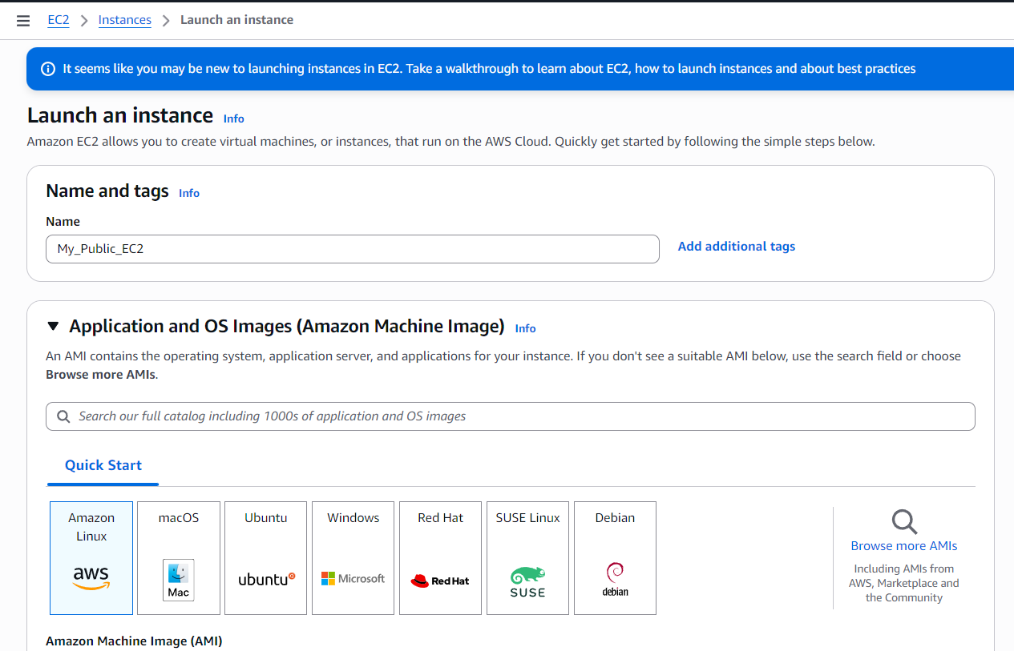
- First, I searched for EC2 in the AWS search bar and opened the EC2 console.
- Then I clicked on Instances from the left-side panel.
(I could also access the same page from the right side by clicking Launch Instance.)
- After clicking Launch Instance, the setup page opened.
- I gave my instance a name: My_Public_EC2.
- Under Amazon Machine Image (AMI), I selected Amazon Linux.
There were other operating system options available, but I chose Linux because it is lightweight, fast to boot, and widely used for AWS practice and cloud projects.

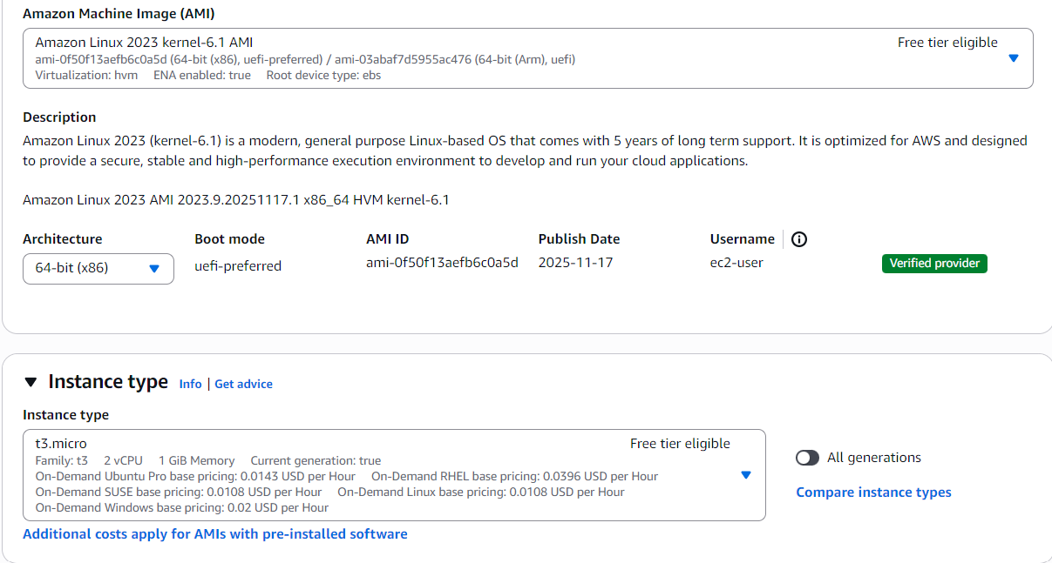
- There was an option to select the architecture, and I chose 64-bit (x86).
This is the standard architecture used for most servers and applications, ensuring compatibility and good performance.
- Next, I had to choose an Instance Type.
An instance type determines the hardware power of your EC2 instance — such as CPU, RAM, and network performance.
Simply put: it decides how strong your virtual machine will be.
- I selected t3.micro.
The t3 family is a burstable performance instance, meaning it provides enough power for general tasks and can temporarily boost performance when needed.
The micro size is the smallest and most cost-efficient, perfect for testing and learning environments.

Key Pair Configuration
- Next was the Key Pair section. A key pair is a secure login credential used to connect to your EC2 instance.
Instead of using a password, AWS gives you a private key file that proves you are the owner of the instance.
- I could either select an already created key pair or proceed without one, but I chose to create a new key pair.
- I named it My_Key_Pair.
- Then I had to choose the key type. There were two options:
  - RSA – the most common and widely supported key type; works with almost all SSH clients.
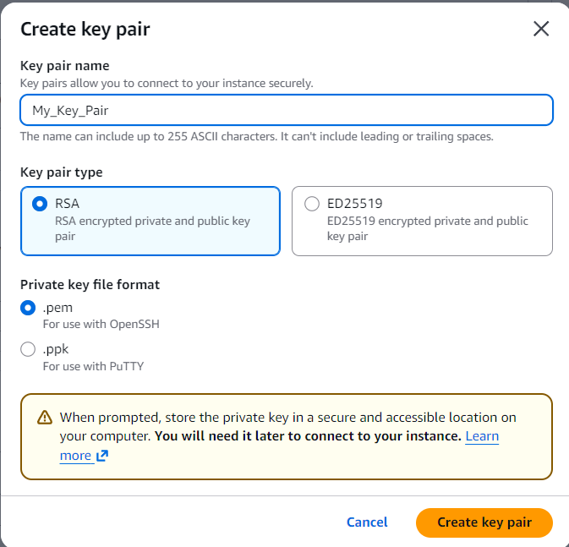
  - ED25519 – a newer, faster, and more secure algorithm, but not supported everywhere.
I selected RSA for maximum compatibility.
- Next was choosing the file format. I selected .pem.
The other option was .ppk, which is mainly used for Windows with PuTTY.
Since I preferred the standard Linux/SSH format, I used .pem.
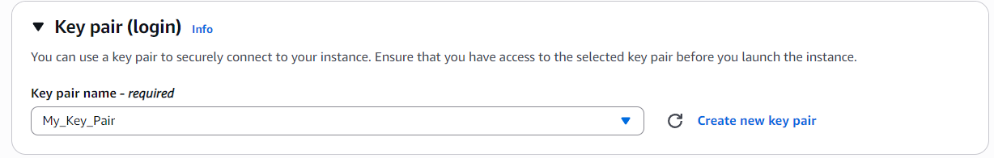
- After clicking Create Key Pair, a private key file was automatically downloaded to my computer. This file is essential for connecting to my EC2 instance later.
Network Settings
- Next was the Network Settings section. Here I had to configure how my EC2 instance would connect within my VPC.
- First, I selected the VPC I created earlier called My_Network_VPC. This ensures the instance launches inside my own custom network instead of the default VPC.
- Then I selected the subnet My_Public_Subnet because this EC2 instance is meant to be publicly accessible from the internet.
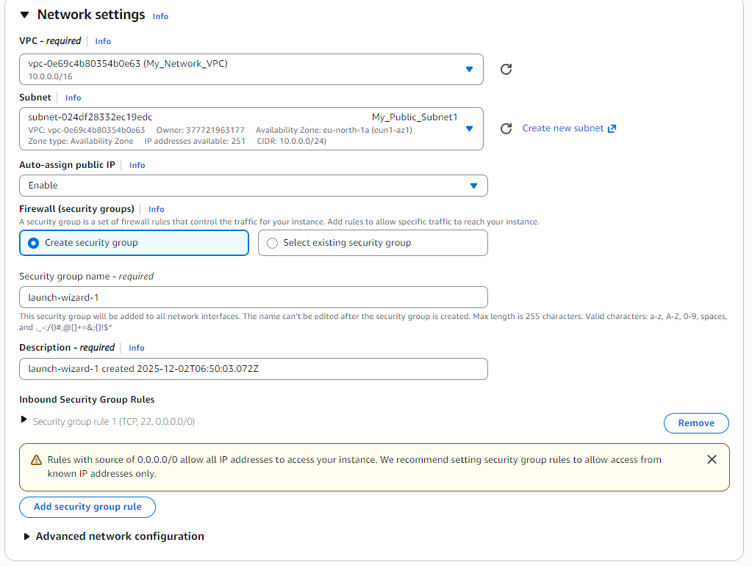
- After that, I enabled Auto-assign Public IP. This setting tells AWS to automatically give my instance a public IP address so it can be accessed from outside the VPC. Without this, the instance would only have a private IP.
- Next was the Firewall (Security Group) section. Here, I selected my previously created security group called My_Public_Security_Group. This security group acts like a virtual firewall that controls what inbound and outbound traffic is allowed for the instance.
- I left the rest of the settings as default, and after reviewing everything, I clicked Launch Instance to create my EC2.
- After the instance was created, I opened the networking panel to review the details.
Here I could clearly see all the network-related settings that were automatically applied or selected during the launch process.
- The panel showed the VPC as My_Network_VPC, confirming that the instance was launched inside the correct custom network.
- The Subnet was listed as My_Public_Subnet, which matched my intention of placing this instance in the public section of my VPC.
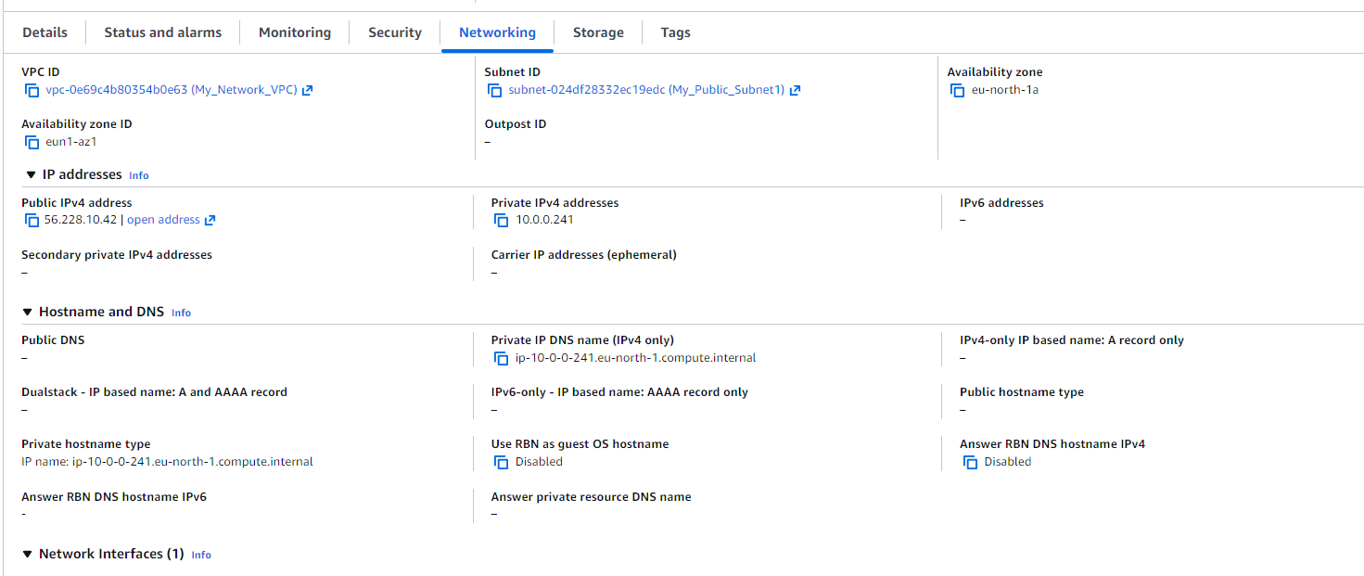
- I could also see that Auto-assign Public IP was enabled, and a public IP address had been assigned to the instance. This means the instance is reachable from the internet (as long as the security group allows access).
Launching a Private EC2 Instance
A private EC2 instance is a virtual machine that cannot be accessed directly from the internet. It is placed inside a private subnet and only has a private IP, which allows communication within the VPC.
Private EC2s are used for backend services, databases, or any resources that need to stay secure and isolated from public access. They rely on routing, NAT gateways, or other public instances if they need temporary internet access.
With this understanding, I proceeded to launch my private EC2 instance inside my private subnet.

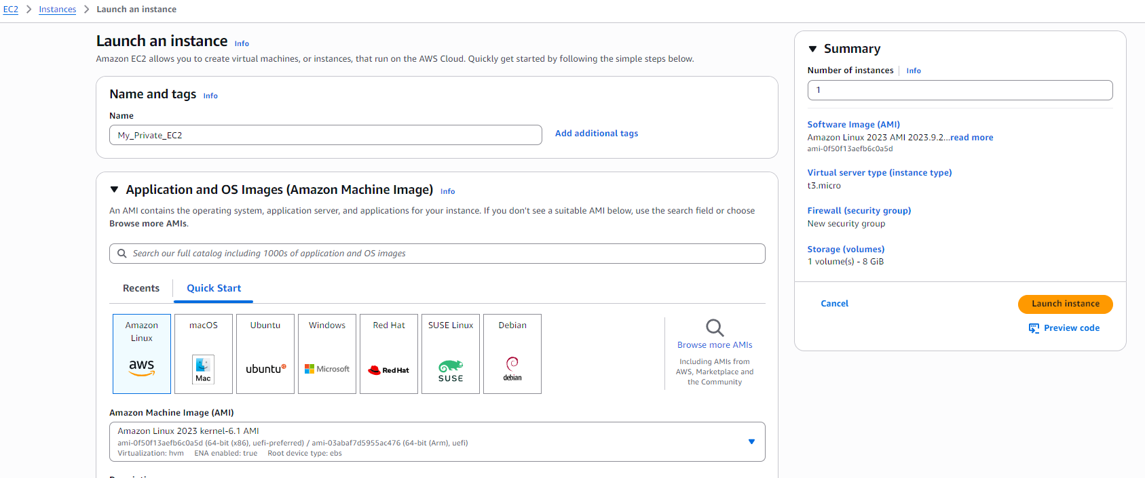
- First, I clicked on Launch Instance to start creating my private resource.
- I gave the instance a name: My_Private_EC2.
- Next, I selected the same operating system as before: Linux (Amazon).
I chose Linux because it is lightweight, widely supported, and ideal for learning and testing in AWS.
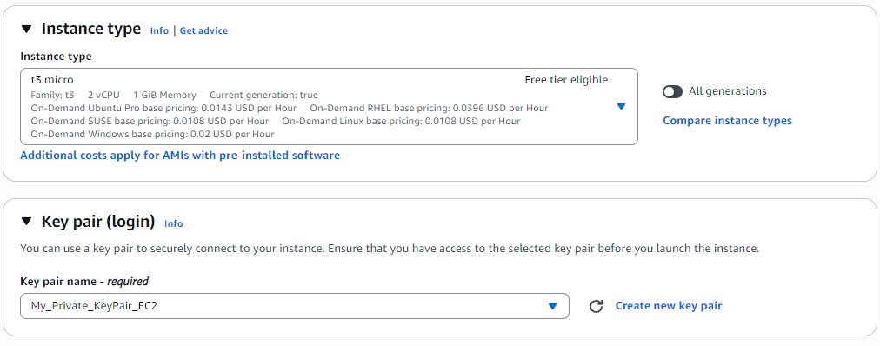
- I chose the same instance type as my public EC2, which is t3.micro, to keep it consistent and lightweight for testing purposes.
- Next, I created a new key pair called My_Private_Keypair_EC2.
This key pair is essential to securely connect to the private instance later, just like with the public EC2.
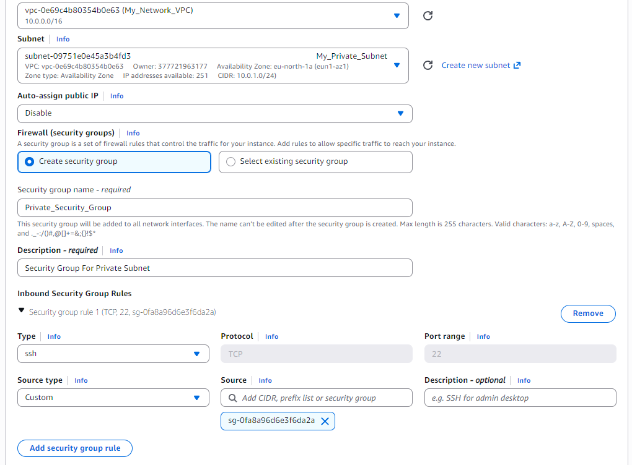
- Next, I configured the networking settings for my private EC2 instance.
- I selected the same VPC I created earlier, My_Network_VPC, to ensure it is part of my custom network.
- For the subnet, I chose My_Private_Subnet, which is designed to be isolated from the internet.
- I disabled Auto-assign Public IP because this instance should remain private and not be directly reachable from the internet.
- In the Firewall (Security Group) section, I created a new security group called Private_Security_Group.
I also added a description indicating it is for the private subnet.
- For the Inbound rule, I selected SSH as the type, set the source type to Custom, and chose my Public_Security_Group as the source.
This ensures that only resources that are part of the public security group—like my public EC2 instance—can communicate with this private EC2.
In other words, it allows internal communication between specific resources while keeping the instance isolated from external access.
- After configuring the network settings and security group, I left all the remaining options at their default values.
- Once I reviewed everything to ensure it was correct, I clicked Launch Instance to create my private EC2.
Creating a VPC Using “VPC and More”
The “VPC and More” option in AWS is a shortcut that lets you create an entire network setup in one go.
Instead of manually creating a VPC, subnets, route tables, internet gateways, and NAT gateways one by one, this option does it all automatically for you.
It’s useful when you want a complete, production-ready network quickly, with public and private subnets, proper routing, and internet access already configured.
Using this option saves time and ensures that all the networking components are correctly connected and ready to use.
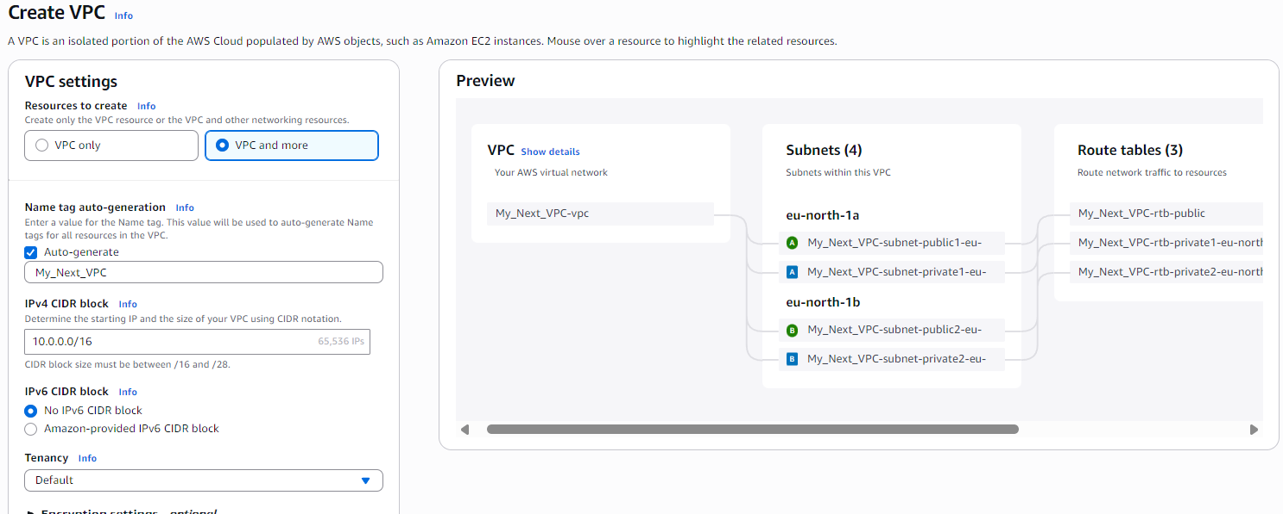
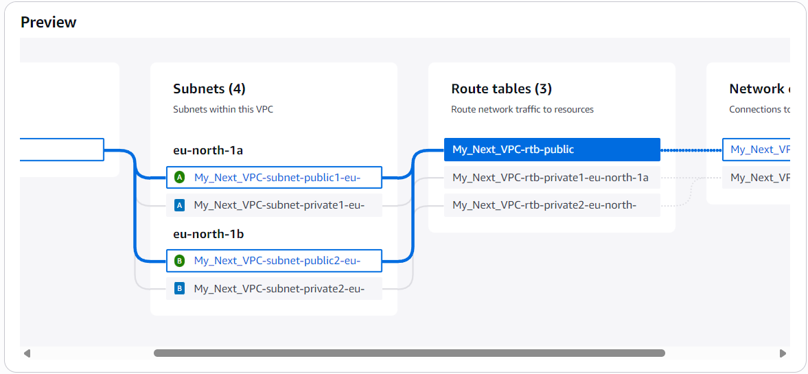
In the preview window on the right side, I noticed that when I moved the cursor over different components, it highlighted the relationships between the network elements.
This made it easy to see how the VPC, subnets, route tables, and internet gateways were connected.
It helps to visualize the network layout before creating it, ensuring that everything is properly linked and organized.
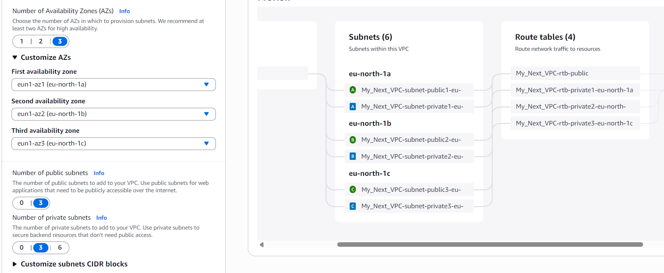
- Any changes I made on the left side were reflected immediately on the right-side preview.
- For example, choosing Availability Zones, selecting the number of public subnets, or even changing the name of the VPC updated the diagram in real time.
- This feature makes it easy to see the effect of each setting and ensures that the network layout matches my intended design before creating the VPC.
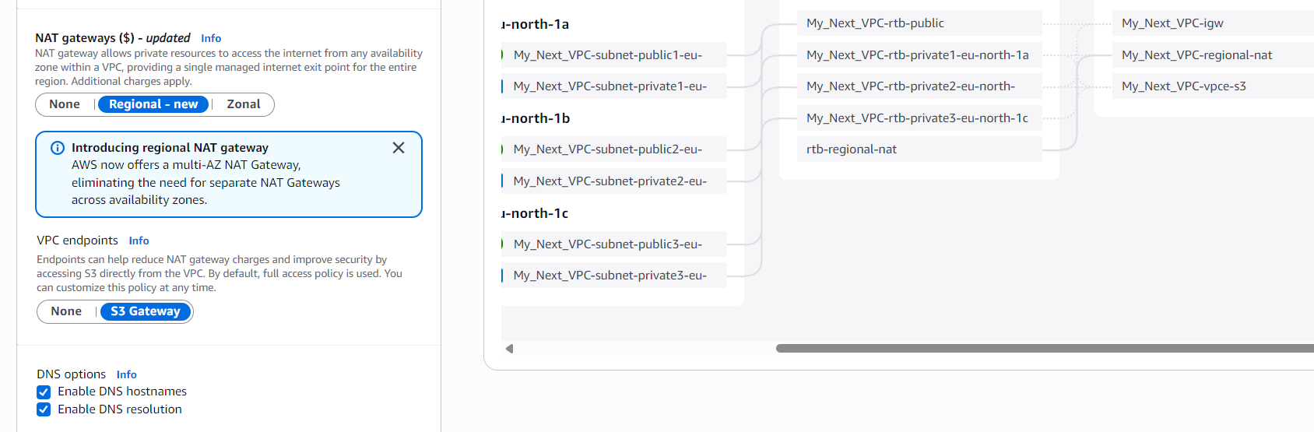
While configuring the VPC, I noticed several optional settings:
- NAT Gateway – This allows private subnets to access the internet. Options include:
  - None – No NAT, private instances cannot reach the internet.
  - Regional – A single NAT gateway for the entire region.
  - Zonal – One NAT gateway per Availability Zone.
- VPC Endpoints – These let your VPC privately connect to AWS services without going through the internet. Options include:
  - None – No private connection.
  - S3 Gateway – Provides a private route to Amazon S3 directly from your VPC.
- DNS Settings – You can enable or disable DNS Hostnames and DNS Resolution.
Enabling these allows instances in the VPC to resolve domain names and access AWS services using hostnames.
These options give more control over internet access, private connectivity, and name resolution within the VPC.
Conclusion
Through this project, I learned how to create and configure EC2 instances both publicly and privately, as well as how to build a complete VPC using the “VPC and More” option.
I now understand how subnets, route tables, security groups, and NAT gateways work together to control network traffic and access.
This hands-on experience strengthened my knowledge of AWS networking, showing me how to design secure and functional cloud environments, manage internal and external communication, and visualize complex network layouts effectively.

